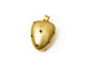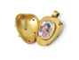

Heart-shaped locket
made of 750 yellow gold
with 14 ruby cabochons,
measurements: 5cm x 4cm x 2.5cm
price on request

Erich Zimmermann
Heilig-Kreuz-Straße 15
D-86152 Augsburg
Germany
Fon +49-821-515195
Fax +49-821-511166
www.erich-zimmermann.com
info@erich-zimmermann.com

Foto: Atelier Zimmermann

