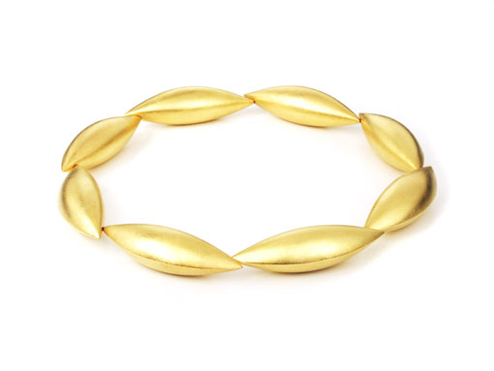

"Cocoon" collier made of 750 yellow gold.

This piece was purchased by the
Crafts Museum of Dresden at the Pillnitz palace
and did win the Town&Country Design Award 2007
in the "Gold" category at the
Couture Jewelry Show in Las Vegas.

Erich Zimmermann
Heilig-Kreuz-Straße 15
D-86152 Augsburg
Germany
Fon +49-821-515195
Fax +49-821-511166
www.erich-zimmermann.com
info@erich-zimmermann.com

Foto: Atelier Zimmermann

