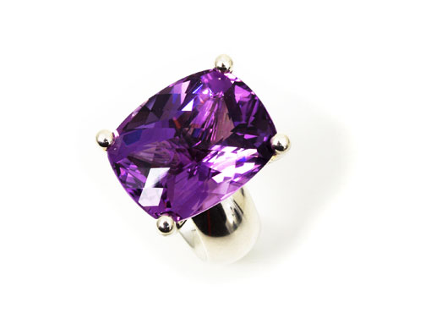

Princess ring made of silver with an
amethyst in cushion cut of 45.80ct

Erich Zimmermann
Heilig-Kreuz-Strasse 15
D-86152 Augsburg / Germany
Fon +49-821-515195
Fax +49-821-511166
www.erich-zimmermann.com
info@erich-zimmermann.com

Foto: Atelier Zimmermann

