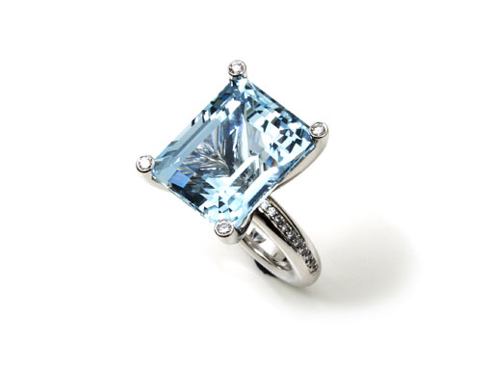

Princess ring made of 750 white gold with an
aquamarine baguette of 27.73ct and
24 brilliant-cut diamonds, totaling 0.40ct

This ring was purchased by John Travolta in Florida.

Erich Zimmermann
Heilig-Kreuz-Strasse 15
D-86152 Augsburg / Germany
Fon +49-821-515195
Fax +49-821-511166
www.erich-zimmermann.com
info@erich-zimmermann.com

Foto: Atelier Zimmermann

