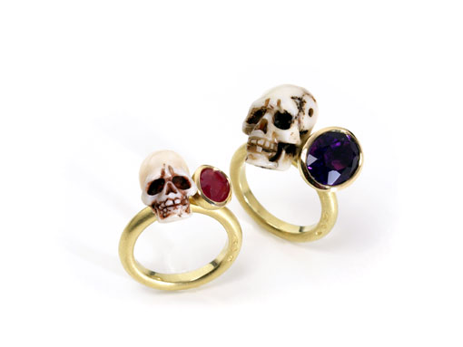

Two pirate rings made of 750 yellow gold.
One ring with a ruby, the other ring with an amethyst,
combined with a skull crafted from white coral.

Erich Zimmermann
Heilig-Kreuz-Strasse 15
D-86152 Augsburg / Germany
Fon +49-821-515195
Fax +49-821-511166
www.erich-zimmermann.com
info@erich-zimmermann.com

Foto: Atelier Zimmermann

